**THE SOCIETY FOR CASE RESEARCH**



**Service Unbounded: A Contract Management Dilemma**

# John Barczak, Notre Dame of Maryland University Elizabeth H. Jones, Notre Dame of Maryland University Scott Shindledecker, Notre Dame of Maryland University

*This critical incident was prepared by the authors and is intended to be used as a basis for class discussion. The views represented here are those of the authors and do not necessarily reflect the views of the Society for Case Research. The views are based on professional judgment. The names of organizations and individuals have been disguised to preserve anonymity. Copyright © 2015 by the Society for Case Research and the authors. No part of this work may be reproduced or used in any form or by any means without the written permission of the Society for Case Research.*

# Introduction

Nathan O’Rourke’s first thought after hanging up the phone was, “Can I get fired for this?” As a representative for the government, he was supposed to make sure the agency’s new laboratory administration contract was performed without incident and according to regulation. The contractor *had* successfully kept the labs operating, but had done so by working outside the scope of the contract. Why did the contractor assume they could work outside of the contractual agreement and why is he just learning about this now? How had this simple service contract gone off track after only a few months? He had to decide what to do. Now!

# Background

The U.S. Government conducted a wide range of science and technology research across many agencies, including the Department of Energy, the Department of Defense, the Environmental Protection Agency, and the National Institutes of Health. Scientific Research Agency conducted basic and applied research for the national defense community and operated several facilities around the country. While most federal agencies received their funding directly from Congress, Scientific Research Agency received its funding from the organizations it serviced. Management of Scientific Research Agency’s operations were especially challenging because it supported many programs, and the agency’s third-party accreditation required extensive documentation.

The national defense community had experienced many changes over the past 15 years. After the attacks of September 11, 2001 a flood of government civilians and contractor personnel were employed to support the global war on terrorism. Following several years of active U.S. military engagement in the Middle East and elsewhere, the U.S. began to pull out of Iraq and Afghanistan, and the requirement for civilian support staff went down dramatically. The government’s decision to use contractor personnel to meet surge requirements made it easier to “right-size” organizations after the mission shrunk because it was simpler to terminate contracts than to fire government employees. As part of the defense community, Scientific Research Agency had to adapt quickly to mission changes, funding cycles, and other influences. In some cases, Scientific

Research Agency decided it could increase its flexibility by outsourcing certain functions that were not inherently governmental in nature.

Eva Crosby, a contracting officer, oversaw Scientific Research Agency’s acquisition of goods and services. Only contracting officers were legally authorized to bind the government to a contractor via written contract. Nathan O’Rourke was a contracting officer’s representative who performed specific technical and administrative functions on Crosby’s behalf in accordance with Defense Procurement and Acquisition Policy (Office of the Under Secretary of Defense for Acquisition, Technology and Logistics, 2014). The contracting officer’s representative acted as the eyes and ears for the contracting officer and monitored the contractor’s execution of the contract on a daily basis.

# The Dilemma

At the start of the fiscal year, Scientific Research Agency identified the need for a support contract to handle some routine administrative functions associated with operating the agency’s research laboratories. These functions included management of unique software tools, management of test results, quality assurance analysis, and management of consumable supplies.

Three months into the fiscal year Crosby, the contracting officer, awarded Engineering Associates, Inc. a Cost Plus Fixed Fee (CPFF) contract that authorized payment of actual expenses plus a set amount of profit. This new laboratory administration contract required the contractor to provide monthly progress reports to the contracting officer’s representative and to the contracting officer. Funding limitations forced the two-year contract to be broken into several smaller time intervals that could be funded incrementally. The base period of performance for the contract was for three months. If funding permitted and the need for the contract continued, the contracting officer could award a series of option periods. Option 1 was for three months, Option 2 was for six months, and Option 3 was for 12 months. If every option were exercised, the full performance period for the contract would be two years. Engineering Associates, Inc. was a small business and this contract was their first one with Scientific Research Agency.

Concurrent with the laboratory administration contract, Scientific Research Agency also prepared to award a new contract for leasing laboratory gas cylinders. These gases included hydrogen, nitrogen, and specialty gases that Scientific Research Agency’s equipment used in its testing operations. Unfortunately, the award for the gas cylinder contract was three months behind schedule. Without the gas cylinders, critical laboratory operations would cease, important research and testing would suffer delays, and restarting at a later time would be costly. This would waste precious resources and inhibit the agency’s ability to perform its mission. In order to sustain laboratory operations, O’Rourke asked Crosby to modify the three-month base period of the laboratory administration contract to include the management of gas cylinders. This would bridge the gap until the stand-alone gas cylinder contract was awarded. Because Engineering Associates, Inc. was already managing some of the lab consumables, Crosby determined that the modification was appropriate and agreed to adjust the contract to include this requirement. Three months passed. The lab administration contract was going well and the first option period was exercised, extending the contract for another three months. Unfortunately, the new cylinder contract still had not been awarded.

O’Rourke notified Crosby of the need to modify the first option period to include cylinder management, as had been done for the base period. This would buy more time as the cylinder contract continued to move toward award. Due to a heavy workload and other complications, it took O’Rourke a month to get the contract modified, as shown in the timeline below.

# *Figure 1.* Timeline showing contract performance periods and subsequent modifications.

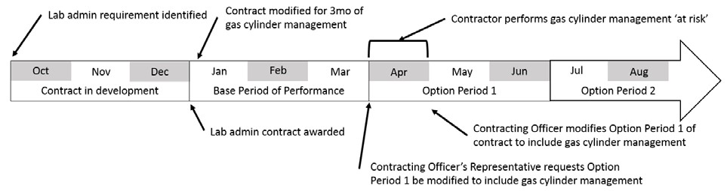

Unbeknownst to O’Rourke, the Engineering Associates, Inc. program manager chose to keep managing the gas cylinders for that month because they understood the impact to the program and they wanted to please their new client. Because the need for gas cylinder management had never stopped, Engineering Associates, Inc. continued to perform this function past the base period of performance, even though their contract stated that they were only to manage the cylinders for three months. This type of situation exemplified working *at risk* because the contractor performed work that the government had not formally agreed to pay for.

After the contract’s modification, O’Rourke learned that the contractor had never stopped managing the cylinders and in actuality had been working at risk. O’Rourke had to decide what to do. Should he let sleeping dogs lie? After all, the contract modification was eventually completed. Or should he notify Eva Crosby, the contracting officer, that unauthorized work had been performed? If he did, would O’Rourke be held legally responsible for the incident? Should Engineering Associates, Inc. be compensated for the cylinder management they performed at risk? Had the relationship between Engineering Associates, Inc. and the government suffered damage? O’Rourke also wondered what might have prevented this situation from occurring in the first place.

# References

Office of the Under Secretary of Defense for Acquisition, Technology and Logistics. (2014).

Defense Procurement and Acquisition Policy (DPAP). Retrieved from<http://www.acq.osd.mil/dpap/index.html>